PROMISE & PRACTICE · DEEP DIVE · SOURCE ANALYSIS
Chickamauga & Chattanooga — A House Divided
From Defeat to Open Door
Name: ______________________________ Period: _____ Date: ________________
WHAT I CAN DO TODAY I can read primary sources about Chickamauga & Chattanooga — A House Divided, weigh who made each one and why, and use evidence to answer historical questions.
Directions. One event sets up the next. Trace the chain from Chickamauga to the gateway of the Deep South

THE SOURCES
THE IMAGE · SEPTEMBER 1863 — The Battle of Chickamauga
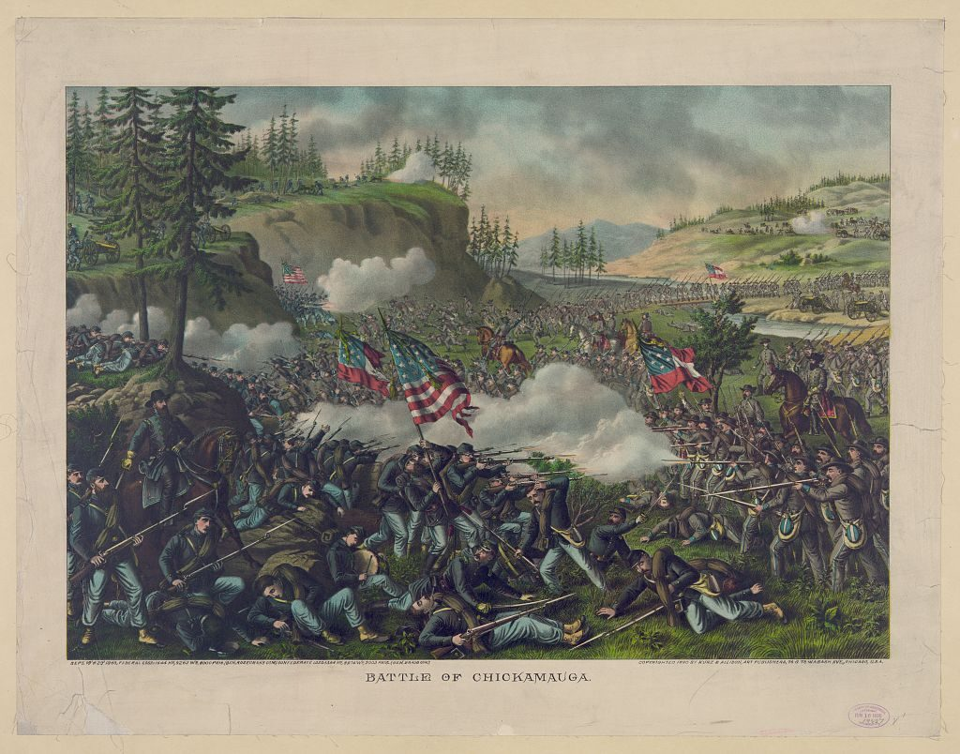
“Battle of Chickamauga, September 19–20, 1863” — chromolithograph, Kurz & Allison, public domain (Library of Congress).
THE IMAGE · NOVEMBER 1863 — The Battle Above the Clouds
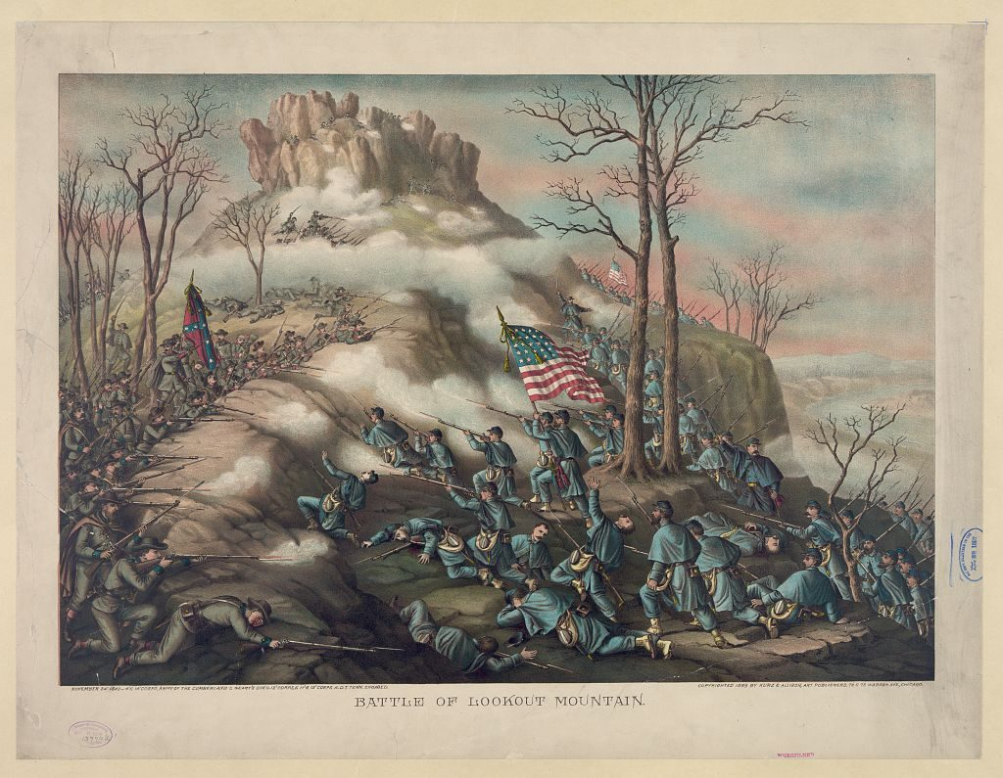
Two months after the disaster at Chickamauga, the same Union army stormed the heights above Chattanooga and reversed the campaign
“Battle of Lookout Mountain, November 24, 1863” — chromolithograph, Kurz & Allison, public domain (Library of Congress).

YOUR WORK
QUESTION 1 STEP 1 · ORDER THE EVENTS
Number these events 1–5 in order: (a) Grant opens the “Cracker Line” · (b) the Union loses at Chickamauga · (c) Union troops storm Missionary Ridge · (d) the Union army is besieged and starving in Chattanooga · (e) the gateway to Georgia opens for Sherman.
____________________________________________________________________________________________
____________________________________________________________________________________________
____________________________________________________________________________________________
QUESTION 2 STEP 2 · THE HINGE
The Union army was trapped and starving in Chattanooga. What was the key cause of its recovery?
☐ A. the Confederates surrendered
☐ B. winter ended the fighting
☐ C. Grant arrived and opened a supply route (the “Cracker Line”)
☐ D. the army retreated to Kentucky
QUESTION 3 STEP 3 · LOST BATTLE, WON CAMPAIGN
The Union lost the Battle of Chickamauga but won the campaign for Chattanooga. Explain how that happened — what did the defeat lead to, and how did the Union turn it around?
____________________________________________________________________________________________
____________________________________________________________________________________________
____________________________________________________________________________________________
____________________________________________________________________________________________
QUESTION 4 STEP 4 · THE NEXT EFFECT
In two or three sentences, explain why taking Chattanooga mattered for the rest of the war. What did it open up, and who would use it in 1864?
____________________________________________________________________________________________
____________________________________________________________________________________________
____________________________________________________________________________________________
____________________________________________________________________________________________
Promise & Practice · ShadowDog Digital Studios · Unit 2

TEACHER ANSWER KEY — Chickamauga & Chattanooga — A House Divided

QUESTION 1: Open response.
Look for a response along the lines of: “1 = ___ 2 = ___ 3 = ___ 4 = ___ 5 = ___”
QUESTION 2: Correct — C. Grant arrived and opened a supply route (the “Cracker Line”)
Right. Grant's arrival and the “Cracker Line” reopened the supply route, feeding and reinforcing the army so it could go back on the offensive.
QUESTION 3: Open response.
Look for a response along the lines of: “The defeat at Chickamauga led to…, but then…”
QUESTION 4: Open response.
Look for a response along the lines of: “Holding Chattanooga opened…, which let Sherman…”

